**THE STUXNET VIRUS**

Investigation & Research Report

horizontal line

# 

horizontal line

**Submitted By: Sukhvir Sahota**

# 

# 

# 

# 

**Table of Contents**

# 

**Executive summary** **2**

**Introduction** **3**

**How Stuxnet Works** **3**

**Victims of the attacks** **5**

Domain A 7

Domain B 8

Domain C 9

Domain D 9

Domain E 10

**Technologies and tools utilized in the attack** **11**

**Time-frame of the attack within the network** **12**

**Systems targeted by the attackers** **14**

**The motivation of the attackers and their objectives** **14**

Why Was Stuxnet Created? 15

Objectives 15

**The outcome of the attack** **16**

**Mitigation Strategies for Stuxnet** **16**

**Conclusion** **17**

**References** **18**

# 

# 

# Executive summary

The Stuxnet virus marked a watershed moment in cyber warfare as the first known cyber weapon. Developed with remarkable sophistication, it primarily targeted Iran's nuclear enrichment facilities, notably the Natanz uranium enrichment plant. Suspected to be a collaboration between the United States and Israel intelligence agencies, Stuxnet was crafted to infiltrate and sabotage industrial control systems, particularly Siemens PLCs.

Stuxnet exploited vulnerabilities in Windows systems, spreading via USB drives and specifically targeting Siemens Step7 software. It aimed to manipulate centrifuges, disrupting Iran's nuclear enrichment process while deceiving operators with false feedback. The attack timeline reveals a calculated and persistent effort spanning several years, resulting in significant disruption to Iran's enrichment program.

Victims of Stuxnet included various Iranian organizations involved in industrial automation, such as Foolad Technic Engineering Co. and Behpajooh Co. Elec & Comp. Engineering. The attack's success prompted global awareness of cyber threats to critical infrastructure, leading to increased vigilance and cybersecurity measures worldwide.

While Stuxnet achieved its goal of disrupting Iran's nuclear ambitions, its long-term impact remains uncertain. Iran likely bolstered its cybersecurity defenses and possibly developed offensive cyber capabilities in response. Mitigation strategies against Stuxnet-like attacks emphasize a multi-layered defense approach, including prevention through security policies, active measures like intrusion detection systems, and reaction protocols such as air-gapping critical systems during an attack.

The Stuxnet virus represents a paradigm shift in cyber warfare, showcasing the potential for cyber weapons to inflict physical damage on critical infrastructure. Its legacy underscores the importance of robust cybersecurity measures and international cooperation to mitigate future threats in our increasingly digitized world.

# Introduction

[Stuxnet](https://www.csoonline.com/article/562691/stuxnet-explained-the-first-known-cyberweapon.html#:~:text=What%20is%20Stuxnet,against%20their%20adversaries.) was an extremely sophisticated, powerful, and malicious computer worm that first surfaced in 2010 and is thought to have been in development since at least 2005. It is considered as the first known cyber-weapon. The original Stunext was a malware attack that targeted programmable logic controllers(PLCs).

The was a classified program with the code name "Operation Olympic Games". The Stuxnet virus is widely believed to have been developed by a collaborative effort between the United States and Israel intelligence. This sophisticated cyber weapon was specifically designed to target Iran's nuclear enrichment facilities, particularly the Natanz uranium enrichment plant.

In this report, we will discuss more about the attack victims, tools and technologies used along with the motivation and outcome of the initial attack.

# How Stuxnet Works

The image provides a detailed step-by-step explanation of how the Stuxnet virus operates, from initial infection to eventual destruction of its targeted systems. Here's a breakdown of the process illustrated:

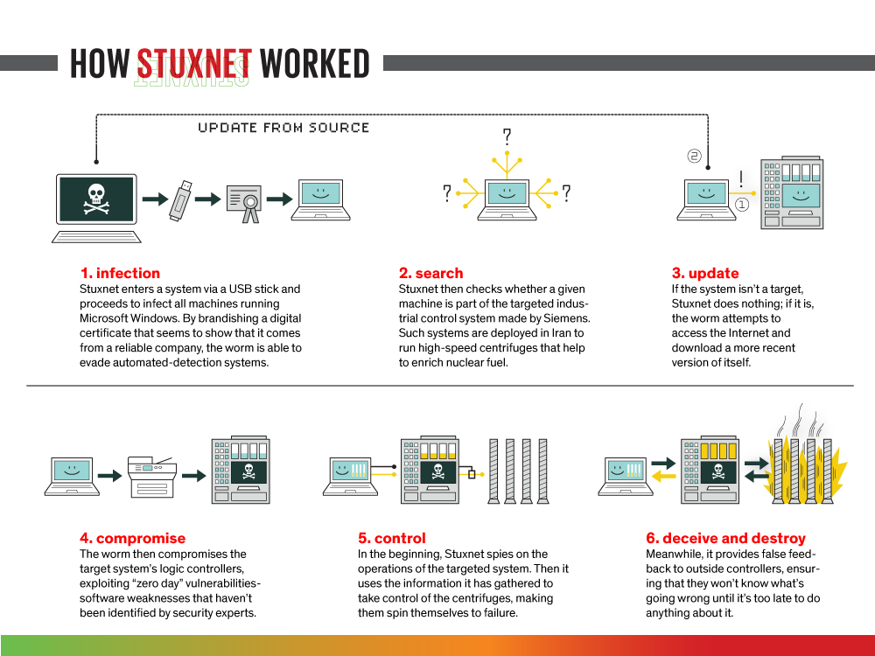

**1. Infection**

* ***Entry Point:*** Stuxnet enters a system via a USB stick. This method exploits the human factor, relying on someone inserting an infected USB into a computer within the targeted network.
* ***Propagation***:
  + ***Network Shares***: Once inside a network, Stuxnet copies itself to network shares using Windows network protocols.
  + ***Zero-Day Vulnerabilities:*** Stuxnet utilized several zero-day vulnerabilities (previously unknown and unpatched flaws) in Windows to spread without detection.
* ***Evasion:*** The worm uses a forged digital certificate that appears to come from a trusted company, allowing it to bypass automated detection systems.

**2. Search**

* ***Target Identification***: Once inside a machine, Stuxnet specifically targets Siemens Step7 software, which is used to program and control programmable logic controllers (PLCs). PLCs are critical for industrial automation.
* ***Specific Target:*** The worm identifies target systems by looking for specific models of PLCs and certain configurations indicative of the Iranian nuclear enrichment process.

**3. Update**

* ***Non-Target Machines:*** If the system is not a target, Stuxnet remains inactive.
* ***Target Machines:*** Once Stuxnet identifies a targeted system, it injects its payload into the PLCs through the Siemens Step7 software.

**4. Compromise**

* ***Compromising Logic Controllers:*** Stuxnet then compromises the target system's programmable logic controllers ([PLCs](https://www.polycase.com/techtalk/electronics-tips/what-is-a-programmable-logic-controller.html#:~:text=What%20Is%20a%20Programmable%20Logic%20Controller%3F,PLCs%20to%20automate%20their%20most%20important%20processes.)) by exploiting "[zero-day](https://www.trendmicro.com/vinfo/us/security/definition/zero-day-vulnerability)" vulnerabilities. In the case of Iran’s Natanz uranium enrichment facility, it altered the speed of centrifuges, causing them to spin at dangerous speeds and eventually fail while reporting normal operation to monitoring systems.

**5. Control**

* ***Initial Surveillance:*** Initially, Stuxnet spies on the operations of the targeted system.
* ***Manipulation:*** It then uses the gathered information to take control of the centrifuges, manipulating their operations to cause them to spin at destructive speeds, ultimately leading to mechanical failure.
* ***Remote Communication:*** Stuxnet includes a command-and-control (C&C) component that allows it to communicate with remote servers to receive updates or new instructions. This communication is encrypted to prevent interception.

**6. Deceive and Destroy**

* ***False Feedback:*** During the attack, Stuxnet provides false feedback to the system operators, making it appear as though everything is functioning normally.
* ***Delayed Detection:*** This deception ensures that operators remain unaware of the ongoing sabotage until it is too late to take corrective actions.

# 

# Victims of the attacks

The primary victim of the Stuxnet virus was Iran's Natanz nuclear facility. The malware specifically targeted the facility's centrifuges used for uranium enrichment. Most uranium that occurs in nature is the isotope U-238; however, the fissile material used in a nuclear power plant or weapon needs to be made from the slightly lighter U-235. A centrifuge is used to spin uranium fast enough to separate the different isotopes by weight via to centrifugal force. These centrifuges are extremely delicate, and it’s not uncommon for them to become damaged in the course of normal operation.

Stuxnet was never intended to spread beyond Iran’s Natanz uranium enrichment. Over time, other groups modified the virus to target facilities including water treatment plants, power plants, and gas lines.

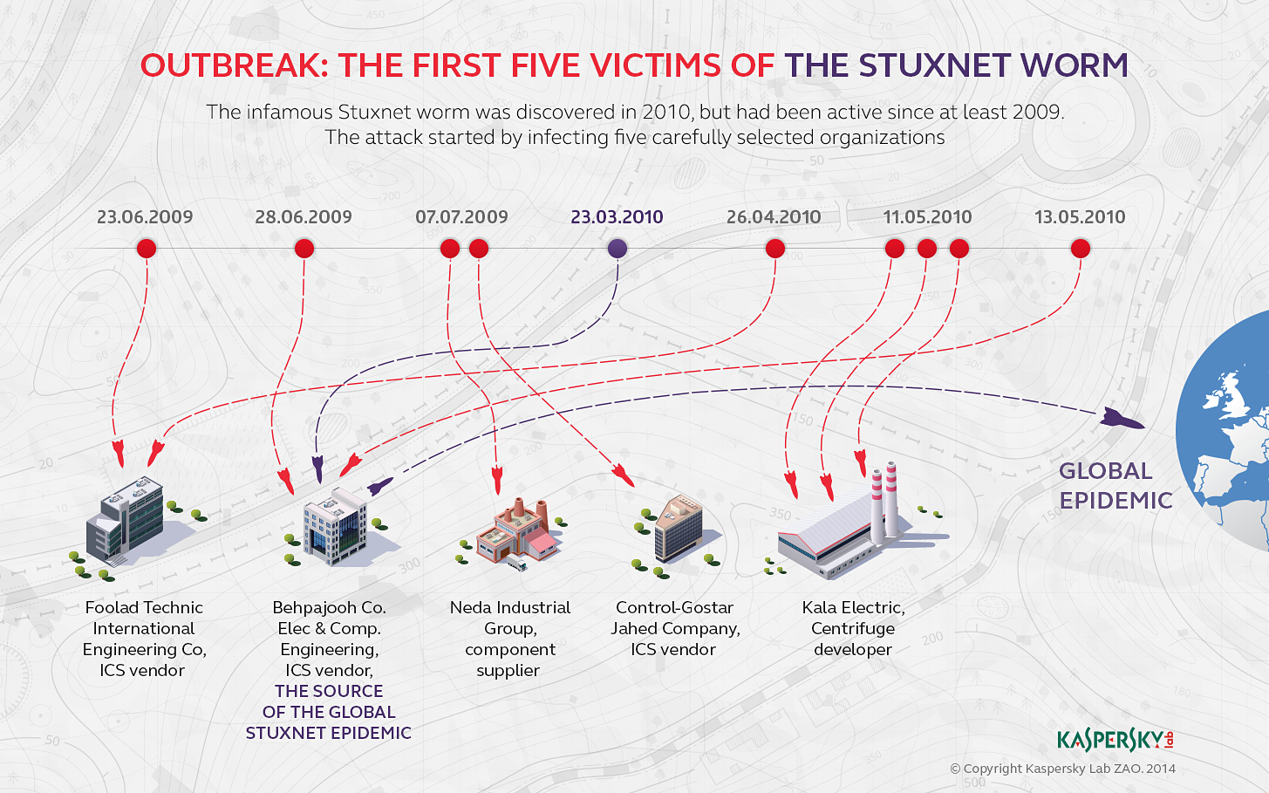

In 2011, Symantec's Security Response team published a new version of its W32.Stuxnet Dossier [report.](https://media.kasperskycontenthub.com/wp-content/uploads/sites/43/2014/11/20082206/w32_stuxnet_dossier.pdf) According to this report, after analyzing more than 2,000 files of worm *Symantec* established that Stuxnet was distributed via five organizations, some of which were attacked twice – in 2009 and 2010.

The [table](https://media.kasperskycontenthub.com/wp-content/uploads/sites/43/2014/11/20082206/w32_stuxnet_dossier.pdf) below shows the details of attack waves against the initial targets

| **Attack Wave** | **Site** | **Compile Date/Time** | **Infection Date/Time** | **Time to Infect** |
| --- | --- | --- | --- | --- |
| Attack Wave 1 | Domain A | June 22, 2009 16:31:47 | June 23, 2009 4:40:16 | 0 days 12 hours |
| Domain B | June 22, 2009 16:31:47 | June 28, 2009 23:18:14 | 6 days 6 hours |
| Domain C | June 22, 2009 16:31:47 | July 7, 2009, 5:09:28 | 14 days 12 hours |
| Domain D | June 22, 2009 16:31:47 | July 19, 2009 9:27:09 | 26 days 16 hours |
| Attack Wave 2 | Domain B | March 1, 2010 5:52:35 | March 23, 2010 6:06:07 | 22 days 0 hours |
| Attack Wave 3 | Domain A | April 14, 2010 10:56:22 | April 26, 2010 9:37:36 | 11 days 22 hours |
| Domain E | April 14, 2010 10:56:22 | May 11, 2010 6:36:32 | 26 days 19 hours |
| Domain E | April 14, 2010 10:56:22 | May 11, 2010 11:45:53 | 27 days 0 hours |
| Domain E | April 14, 2010 10:56:22 | May 11, 2010 11:46:10 | 27 days 0 hours |
| Domain B | April 14, 2010 10:56:22 | May 13, 2010 5:02:23 | 28 days 18 hours |

### Domain A

The first known version of the Stuxnet worm, referred to as ***Stuxnet.a***, was created on June 22, 2009. Remarkably, it infected its first computer just a few hours after its creation, suggesting that the infection was unlikely to have occurred via a USB drive due to the short time frame.

The initial infection occurred on a computer named “KASPERSKY” it was part of the, “ISIE” domain. After investigating, it was determined that the infected organization was ***Foolad Technic Engineering Co. (***[***FIECO***](https://www.fooladtechnic.ir/en/)***)***, an Iranian company based in Isfahan that specializes in creating automated systems for industrial facilities, primarily in steel and power production.

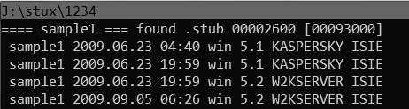

Image source: [securelist.com](http://securelist.com)

FIECO's network contained critical data and plans for Iran’s largest industrial enterprises, making it a valuable target for Stuxnet, which included espionage functions to collect information on [STEP 7 projects](https://mall.industry.siemens.com/mall/en/WW/Catalog/Products/10314843?tree=CatalogTree&ActiveTab=2). This same computer “KASPERSKY.ISIE” in the same organization was targeted again in 2010 with a newer version of Stuxnet, demonstrating the worm creators' persistent interest in FIECO as both a conduit to their final target and a source of industrial intelligence​.

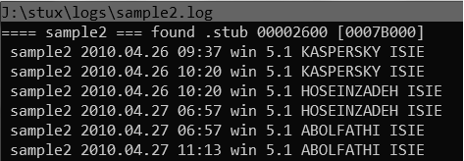

Image source: [securelist.com](https://media.kasperskycontenthub.com/wp-content/uploads/sites/43/2014/11/08071002/great_stuxnet_06.png)

### Domain B

[Behpajooh Co. Elec & Comp](https://www.behpajooh.net/). Engineering was another organization repeatedly targeted by Stuxnet, infected in June 2009, March 2010, and May 2010. This company, like Foolad Technic, is located in Isfahan and develops industrial automation systems, making it a critical node in Iran's industrial network.

The March 2010 infection was particularly significant, marking the starting point of the [global Stuxnet epidemic](https://securelist.com/stuxnet-zero-victims/67483/#:~:text=It%20should%20be%20noted,reasons%20for%20that%20below.): by the summer of 2010, the worm reached companies in Russia and Belarus. Stuxnet 2010 (a.k.a. *Stuxnet.b*) was, compiled on March 1, 2010, and first infected a Behpajooh computer on March 23. Notably, this computer often connected to the company's local network, indicating it might have been a laptop, which facilitated the spread of Stuxnet within and beyond Behpajooh.

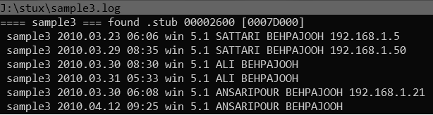

Image source: [securelist.com](https://securelist.com/stuxnet-zero-victims/67483/)

On April 24, 2010, the worm spread extensively from Behpajooh to Mobarakeh Steel Company ([MSC](https://en.wikipedia.org/wiki/Mobarakeh_Steel_Company)), Iran's largest steel maker. The screenshot below shows, that on April 24, 2010, Stuxnet spread from the corporate network of Behpajooh to another network, which had the domain name MSCCO.

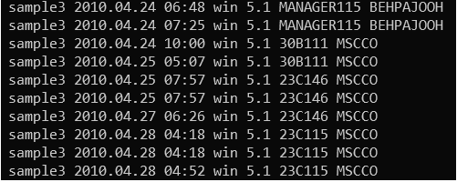

Image source: [securelist.com](https://securelist.com/stuxnet-zero-victims/67483/)

MSC's extensive network connections facilitated the widespread dissemination of Stuxnet, resulting in thousands of systems being infected globally within months. This persistence highlights the strategic targeting by Stuxnet's creators to impact Iran's industrial infrastructure deeply​.

### Domain C

On July 7, 2009, Stuxnet targeted the [Neda Industrial Group](https://nedaco.com/), a company identified by its computer as named “***app-server***” in the NEDA domain. Neda Industrial Group, listed on the U.S. sanctions list, was involved in exporting prohibited entities with potential military applications.

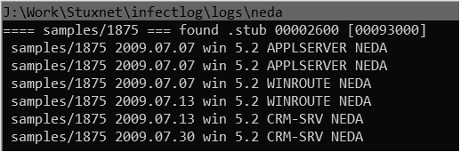

Neda's branches include Nedaye Micron Electronic Company in Tehran and Neda Overseas Electronics LLC in Dubai, providing industrial automation services. Although Stuxnet infected Neda only once and didn't spread beyond, its primary purpose here was likely to gather intelligence on STEP 7 projects used in industrial control systems​.

### Domain D

The fourth victim in 2009 was infected on July 7, the same day Neda Industrial Group was compromised, Stuxnet also infected Control-Gostar Jahed Company ([CGJ](http://www.control-gostar.com/)). The infection started with a server named "SRV1" in the CGJ domain.

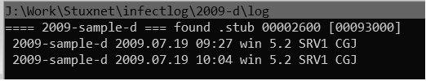

Control-Gostar Jahed, based in Tehran, specializes in industrial automation, offering services in the design, procurement, construction, and commissioning of control systems, among other engineering services. Although not on the sanctions list, CGJ was targeted due to its significant collaborations with major Iranian industries in oil, metallurgy, and energy.

This attack did not spread beyond CGJ's corporate network and represents one of the smaller propagation lines of Stuxnet​.

### Domain E

On May 11, 2010, Stuxnet targeted its fifth victim, infecting three computers named "KALASERVER," "ANTIVIRUSPC," and "NAMADSERVER" simultaneously. This infection pattern strongly suggests that the attack did not originate from an email attachment.

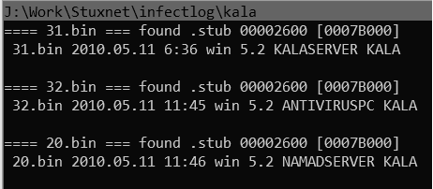

The likely target was Kala Electric ([Kalaye Electric Co](http://www.iranwatch.org/iranian-entities/kalaye-electric-company).), a key player in Iran’s nuclear program and the main manufacturer of the IR-1 uranium enrichment centrifuges. Kala Electric, originally a private company bought by the Atomic Energy Organization of Iran (AEOI), played a crucial role in centrifuge development and testing.

This targeted attack aimed to disrupt Iran's nuclear enrichment efforts, aligning perfectly with Stuxnet's objective of rendering centrifuges inoperable. Despite being a prime target, it is noteworthy that Kala Electric was not attacked in 2009.

# Technologies and tools utilized in the attack

* **Programming Languages**:

Security researchers do not have direct access to the Stuxnet source code, their analysis has revealed significant insights. They determined that Stuxnet was written in [multiple programming languages](https://www.computerworld.com/article/1539067/is-stuxnet-the-best-malware-ever.html), including C, C++, and likely several other object-oriented languages. This multilingual approach is atypical for malware and underscores the high level of sophistication involved in its development. This complexity highlights the advanced capabilities and resources of the team behind Stuxnet.

* **Components:**

STUXNET comprises three interlinked components—a worm, an .LNK file, and a rootkit.

* + ***Worm (WORM_STUXNET)***: The brains of the operation. It leverages specific vulnerabilities for its dissemination and execution of key functions. Utilizing a Microsoft Remote Procedure Call, it executes designated operations, facilitating communication among affected systems. Additionally, it checks for an active Internet connection on the compromised system to establish communication with a remote server. Moreover, it endeavors to access a database akin to those utilized in Siemens WinCC systems.
  + ***Autorun Shortcut (LNK_STUXNET):*** This cleverly crafted .LNK file, automatically triggers the propagation of WORM_STUXNET copies. It exploits a vulnerability in Windows' method of displaying shortcut file icons, primarily serving STUXNET for automated execution.
  + ***Rootkit (RTKT_STUXNET):*** The RTKT_STUXNET, functioning as a rootkit component, primarily conceals all malicious files and processes. This action aims to prevent the infection from being detected by the user, thus maintaining stealth in its operation.
* **First-Known PLC Rootkit**:

Stuxnet broke new ground by specifically targeting Programmable Logic Controllers ([PLCs](https://www.sciencedirect.com/topics/computer-science/stuxnet#:~:text=Many%20security%20companies%2C%20including%20Symantec,stolen%20certificates%20from%20trusted%20CAs.)) - industrial control systems that manage critical infrastructure. It deployed the first-ever PLC rootkit, designed to manipulate these controllers and disrupt industrial processes.

* **Antivirus Evasion Techniques:**

Stuxnet employed various methods to avoid detection by antivirus software, making it even harder to stop its spread.

* **Peer-to-Peer Updates:**

Stuxnet included a peer-to-peer (P2P) communication mechanism that allowed it to update itself. Infected systems could exchange updates with each other, ensuring that the worm could evolve and stay ahead of security measures.

* **Stolen Certificates:**

Stuxnet used digital certificates stolen from trusted Certification Authorities (CAs). These certificates served as a cloak of legitimacy, making the malware appear like genuine software and bypassing security measures.

* **Command and control (C&C) infrastructure:**

Stuxnet had a complex C&C infrastructure that allowed the attackers to remotely control and monitor the infected systems. This infrastructure included multiple layers of communication and used various protocols to evade detection.

# Time-frame of the attack within the network

The Stuxnet attack was meticulously planned over several years with the intention of causing physical damage to Iran's enrichment facility. In the [image](https://www.google.com/imgres?imgurl=https%3A%2F%2Fwww.researchgate.net%2Fpublication%2F324582305%2Ffigure%2Ffig3%2FAS%3A1042664577318912%401625602015291%2FTimeline-of-the-Stuxnet-cyberattack-Red-arrows-top-indicate-events-driven-by-the.png&tbnid=M9pG1yvXSbkWYM&vet=12ahUKEwj7pvKp1qSGAxUWEWIAHQFQDPEQMygAegQIARBM..i&imgrefurl=https%3A%2F%2Fwww.researchgate.net%2Ffigure%2FTimeline-of-the-Stuxnet-cyberattack-Red-arrows-top-indicate-events-driven-by-the_fig3_324582305&docid=cWWHaw7ZKUjQnM&w=850&h=391&q=Time%20frame%20of%20the%20Stuxnet%20Attack&ved=2ahUKEwj7pvKp1qSGAxUWEWIAHQFQDPEQMygAegQIARBM), red arrows (top) indicate events driven by the attacker(s). The blue arrows (bottom) indicate the reactions of the global community. ([resource](https://www.researchgate.net/publication/324582305_Examining_Cybersecurity_of_Cyberphysical_Systems_for_Critical_Infrastructures_Through_Work_Domain_Analysis))

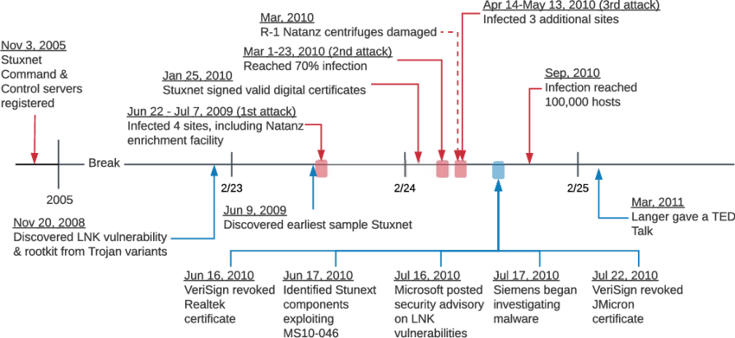

The breakdown of the timeline and key events:

1. **Nov 3, 2005:**

The attacker registers command and control (C&C) servers.

1. **June 22, 2009:**

Suspected launch of the first major attack, infecting four major sites, including the Natanz uranium enrichment facility in Iran, within 26 days.

1. **January 25, 2010:**

The attacker steals the Realtek Semiconductor digital certificate, which is then used to sign the Stuxnet rootkit driver, enabling the compromise of the authentication process.

1. **March 2010:**

The most successful attack occurs, resulting in 70% of all infections. It's estimated that more than 1,000 IR-1 centrifuges at the Natanz facility were damaged.

1. **April-May 2010:**

Further major attacks infect three additional sites.

1. **September 2010:**

Stuxnet infects approximately 100,000 hosts globally, with over 80% of infections in Iran, Indonesia, and India.

1. **Late 2008 to mid-2010**:

Discovery of key components of Stuxnet, including the LNK file vulnerability in November 2008, the associated rootkit malware in June 2009, and other major components between June and July 2010.

1. **June-July 2010:**

Discovery and patching of three major zero-day exploits (LNK file vulnerability, MS10-046, and MS10-061) by Microsoft. Siemens begins investigating malware reports, and VeriSign revokes the RealTek and JMicron digital certificates.

1. **September 30, 2010**:

Symantec presents the first comprehensive analysis of Stuxnet in the Virus Bulletin.

1. **November 2010:**

The Iranian President confirms the Stuxnet attack on the Natanz enrichment facility.

# 

# Systems targeted by the attackers

Stuxnet targeted specific industrial control systems, primarily those using Siemens Step7 software to control PLCs. The primary focus was on the centrifuges at Iran's Natanz facility, aiming to disrupt uranium enrichment processes. The malware specifically targeted:

**Industrial Control Systems (ICS):** Siemens Step7 software and [S7-300 PLCs](https://www.siemens.com/global/en/products/automation/systems/industrial/plc/simatic-s7-300.html).

**Windows Operating Systems:** Leveraging zero-day vulnerabilities to gain access and [propagate](https://www.trendmicro.com/vinfo/fr/threat-encyclopedia/web-attack/54/stuxnet-malware-targets-scada-systems#:~:text=How%20does%20STUXNET,over%20the%20network.).

* Initially, it exploits the MS10-046 Windows shortcut vulnerability ([CVE-2010-2568](https://nvd.nist.gov/vuln/detail/CVE-2010-2568)), enabling its propagation through removable drives, even in cases where Autorun is deactivated.
* Following this, it capitalizes on the MS08-067 vulnerability ([CVE-2008-4250](https://nvd.nist.gov/vuln/detail/cve-2008-4250)) to disseminate across networks, akin to the method employed by DOWNAD/Conficker.
* Lastly, it utilizes the MS10-061 Printer Spooler vulnerability ([CVE-2010-2729](https://nvd.nist.gov/vuln/detail/CVE-2010-2729)) to spread through networks, particularly targeting systems sharing a printer over the network.

# 

# The motivation of the attackers and their objectives

There is no clear indication of the motivation, however, according to [Matisoft labs](https://www.matisoftlabs.com/case-studies/stuxnet), the Stuxnet attack can be understood through various geopolitical, strategic, and technical lenses.

### Why Was Stuxnet Created?

Here's a breakdown of the motivations behind the Stuxnet attack:

**Global Tensions:** Many believe Stuxnet was a response to concerns about Iran's nuclear program, particularly from Western nations like the US and Israel. Stuxnet's focus on disrupting centrifuges at the Natanz facility aligns with this view.

**Nuclear Non-Proliferation:** The attack may have aimed to hinder Iran's ability to develop nuclear weapons, supporting broader international efforts to prevent such proliferation.

**Covert Operation:** Stuxnet represents a stealthy way to achieve strategic goals without resorting to open military conflict. Cyberattacks can be difficult to attribute, reducing the risk of direct confrontation and political backlash.

### Objectives

**Disrupting Nuclear Enrichment:** The primary aim of Stuxnet was to compromise Iran's nuclear enrichment facilities by targeting the Siemens Step7 software and Programmable Logic Controllers (PLCs). It caused the centrifuges to spin at damaging speeds, physically degrading the equipment and hindering the enrichment process.

**Stealthy Sabotage:** A key objective was to carry out the sabotage in a way that remained undetected for as long as possible. Stuxnet's sophisticated design allowed it to manipulate the control systems to show normal operations while the centrifuges were being damaged.

**Demonstrating Cyber Warfare Capabilities:** Stuxnet served as a demonstration of the potential for cyber warfare to cause physical damage to critical infrastructure, setting a precedent for future cyber operations.

**Psychological Impact:** Beyond the physical disruption, Stuxnet aimed to instill fear, uncertainty, and a sense of vulnerability in the Iranian leadership and technical staff by showing that their critical infrastructure could be covertly attacked.

**Intelligence Gathering:** By infiltrating Iran's nuclear facility, Stuxnet also aimed to collect valuable intelligence on its operations, capabilities, and technological progress, which could inform future strategies and policies regarding Iran’s nuclear ambitions.

# 

# The outcome of the attack

**Disrupted Iranian Enrichment:** Experts believe Stuxnet successfully d[amaged over 1000 centrifuges](https://gemserv.com/our-thoughts/stuxnet-the-first-cyber-weapon/#:~:text=Stuxnet%20did%20not%20result%20in,the%20manner%20they%20operated%20marginally.) at Iran's Natanz facility, likely setting back their nuclear enrichment program.

**Limited Physical Damage**: While disruptive, Stuxnet likely didn't cause widespread destruction at the facility. There were no reported explosions or major safety incidents.

**Uncertain Long-Term Impact:** The exact long-term impact on Iran's nuclear program is unclear. Iran may have been able to rebuild or replace damaged centrifuges, although it likely caused delays.

**Increased Global Awareness**: The Stuxnet attack served as a wake-up call for nations and industries regarding the vulnerability of critical infrastructure to cyberattacks. It led to an increased focus on cyber security measures for industrial control systems.

**Debate Over Attribution:** No country has officially claimed responsibility for creating Stuxnet. However, the US and Israel are widely suspected to be involved due to their opposition to Iran's nuclear program and the attack's sophistication.

**Escalation in Cyber Warfare:** Stuxnet is often cited as the first known instance of a cyber weapon causing physical damage. Its success demonstrated the effectiveness of cyber operations, potentially inspiring similar attacks and leading to an arms race in cyber capabilities among nations.

**Iran’s Countermeasures and Cyber Capabilities**: In response to Stuxnet, Iran likely invested in enhancing its own cybersecurity and cyber warfare capabilities. The attack may have spurred Iran to develop more robust defenses and potentially offensive cyber tools as a deterrent against future attacks.

# 

# Mitigation Strategies for Stuxnet

According to [Scadahacker.com’s](https://scadahacker.com/resources/stuxnet-mitigation.html) investigation of Joel Langill’s reach paper on the Stuxnet worm which was reviewed and amended by the CSFI Stuxnet Project Team (<http://www.csfi.us>), Stuxnet mitigation requires a comprehensive, multi-layered defense strategy. No single solution can block such attacks, but a combination of policies and procedures can significantly reduce the impact.

The Mitigation Phases are explained below:

1. **Prevention:**

* ***Passive Measures:***
  + Implement effective security policies and regularly update them.
  + Create and maintain security awareness programs.
  + Disable USB devices in secure zones and enforce software restriction policies.
  + Remove default usernames/passwords and unnecessary services.
  + Follow guidelines like those from the U.S. Dept. of Homeland Security.
* ***Active Measures:***
  + Install host-based firewalls, antivirus, and intrusion detection systems.
  + Use non-repudiation methods for logging and separate devices for log storage.
  + Prefer whitelisting security applications and enforcing strict firewall rules.
  + Ensure code signing for all critical systems.

1. **Reaction:**

* ***Passive Measures:***
  + Use Security Information and Event Management (SIEM) systems to analyze logs.
  + Implement intrusion monitoring and extrusion detection systems.
  + Deploy passive vulnerability scanners and SCADA honeypots for real-time threat analysis.
* ***Active Measures:***
  + Air-Gapping Critical Systems by isolating affected systems during an attack to prevent spread.
  + Follow incident response and business continuity plans.
  + Securely maintain forensic data for post-event analysis.
  + Be prepared to shut down systems as a last resort to protect against severe consequences.

Apart from this Eric Byres and Scott Howard of Byres Security wrote a white paper on the analysis of Siemens WinCC/ PCS7, review the [document](https://drive.google.com/file/d/1Tca_UQNmOJrOwc2mWU0o1gEhYMC70Aw8/view?usp=sharing) for details.

By integrating these preventative and reactive countermeasures, organizations can create a robust defense-in-depth strategy against Stuxnet-like attacks.

# 

# Conclusion

The Stuxnet attack marked a turning point in cyber warfare, showcasing the ability to inflict real-world damage through cyber weapons. While the full extent of its impact on Iran's nuclear program remains unclear, it undoubtedly caused significant disruption and served as a wake-up call for the global community.

The attack highlighted the vulnerabilities of critical infrastructure to cyberattacks and spurred a heightened focus on cybersecurity measures for industrial control systems. Stuxnet's complexity also raised concerns about an escalating cyber arms race among nations.

The success of Stuxnet underscores the importance of a multi-layered defense strategy against such attacks. This includes implementing robust security policies, deploying preventative measures like firewalls and intrusion detection systems, and having a well-defined incident response plan in place. By adopting a holistic approach, organizations can significantly reduce the risk of falling victim to Stuxnet-like attacks and protect their critical infrastructure.

Furthermore, the potential attribution of Stuxnet to the US and Israel raises ethical questions about the use of cyber weapons in international relations. As cyber capabilities continue to evolve, fostering international cooperation and establishing norms for responsible cyber behavior will be crucial in mitigating future threats and maintaining global stability.

# 

# 

# 

# 

# 

# References

1. *CsFi.us: CSFI - Cyber Security Forum Initiative*. (n.d.). <http://www.csfi.us/>
2. *Examining cybersecurity of cyberphysical systems for critical infrastructures through work domain analysis*. (2018). <https://doi.org/10.1177/0018720818769250>
3. Falliere, N., O Murchu, L., Chien, E., & Symantec Security Response team. (2011a). *W32.Stuxnet dossier* (pp. 1–68). <https://media.kasperskycontenthub.com/wp-content/uploads/sites/43/2014/11/20082206/w32_stuxnet_dossier.pdf>
4. Falliere, N., O Murchu, L., Chien, E., & Symantec Security Response team. (2011b). *W32.Stuxnet dossier* (pp. 1–68). <https://media.kasperskycontenthub.com/wp-content/uploads/sites/43/2014/11/20082206/w32_stuxnet_dossier.pdf>
5. FooladTechnic Is An International Engineering Company. (n.d.). *FooladTechnic is an international engineering company*. FooladTechnic Is an International Engineering Company. <https://www.fooladtechnic.ir/en/>
6. Fruhlinger, J. (2022, August 31). *Stuxnet explained: The first known cyberweapon*. CSO Online. <https://www.csoonline.com/article/562691/stuxnet-explained-the-first-known-cyberweapon.html#:~:text=What%20is%20Stuxnet,against%20their%20adversaries>.
7. Keizer, G. (2010, September 16). Is Stuxnet the “best” malware ever? *Computerworld*. https://www.computerworld.com/article/1539067/is-stuxnet-the-best-malware-ever.html
8. *Matisoft case studies page*. (n.d.). <https://www.matisoftlabs.com/case-studies/stuxnet>
9. *Mitigation Strategies for Stuxnet - SCADAHacker*. (n.d.). <https://scadahacker.com/resources/stuxnet-mitigation.html>
10. *Securelist | Kaspersky’s threat research and reports*. (n.d.). Securelist. <http://securelist.com/>
11. *SIMATIC S7-300 - Proven multiple times!* (n.d.). siemens.com Global Website. <https://www.siemens.com/global/en/products/automation/systems/industrial/plc/simatic-s7-300.html>
12. *STEP 7 Professional (TIA Portal) - Industry Mall - Siemens WW*. (n.d.). <https://mall.industry.siemens.com/mall/en/WW/Catalog/Products/10314843?tree=CatalogTree&ActiveTab=2>
13. *Stuxnet - the first cyber weapon - Gemserv*. (2021, March 1). Gemserv. <https://gemserv.com/our-thoughts/stuxnet-the-first-cyber-weapon/#:~:text=Stuxnet%20did%20not%20result%20in,the%20manner%20they%20operated%20marginally>.
14. *STUXNET Malware Targets SCADA Systems - Encyclopédie des menaces*. (n.d.). <https://www.trendmicro.com/vinfo/fr/threat-encyclopedia/web-attack/54/stuxnet-malware-targets-scada-systems#:~:text=How%20does%20STUXNET,over%20the%20network>.
15. *Zero-Day vulnerability*. (n.d.). <https://www.trendmicro.com/vinfo/us/security/definition/zero-day-vulnerability>